NAMIT LOHARKAR BT22CIV101

EXPERIMENT NO. - 6

**Designing a proximity-based smart watch using ESP32, BLE, and PIR sensor for controlling smart home devices**

**Aim:**

Consider a smartwatch as a client and ESP32 smart home device as a server. The system must consist of following features:

1. The smartwatch must be energy efficient i.e. turn ON the watch display if a motion is detected and turn OFF the display after 15 seconds of inactivity.
2. On sensing the motion in room, turn ON the light of the room and set the light intensity according to Table 1. Also, turn ON the AC and set at particular temperature with reference to Table 1.
3. On motion detection turn ON the coffee maker according to Table 1 and inform user that coffee is ready by sending a text.

Table 1.

|  |  |  |  |
| --- | --- | --- | --- |
| Time | Light intensity | AC temp. | Coffee maker |
| 7:00 am to 11:00 am | 50% | 25 | ON |
| 11:00 am to 4:00 pm | 75% | 20 | OFF |
| 4:00 pm to 7:00 pm | 100% | 25 | ON |
| 7:00 pm to 10:00 pm | 100% | 20 | OFF |
| 10:00 pm to 7:00 am | 25% | 15 | OFF |

**Apparatus:**

* Laptop/PC with Arduino IDE installed
* ESP32 Development Board
* Motion detector
* Connecting jumper Wires
* USB Cable (for connecting ESP32 to laptop/PC).

**Theory -**

This experiment explores how a proximity-based smartwatch utilizing BLE and PIR sensors can manage a smart home through the ESP32 microcontroller. BLE’s low power use is ideal for wearable devices, while the ESP32 allows direct interaction with smart home systems, including lighting and temperature adjustments.

**PIR Sensor Role**

The PIR sensor detects motion by sensing body-emitted infrared radiation. It activates the ESP32, which then communicates with connected devices. By tuning the PIR’s settings, this sensor can control smart home functions such as lighting and temperature based on proximity.

**System Design and Power Efficiency**

The ESP32 handles input from sensors and relays commands via BLE. Its power-saving modes minimize battery use by entering a deep sleep state without detected motion, extending battery life and enhancing the user experience..

**ESP32 required pin diagram-**

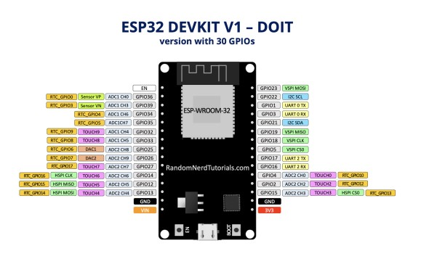

**Connection diagram-.**

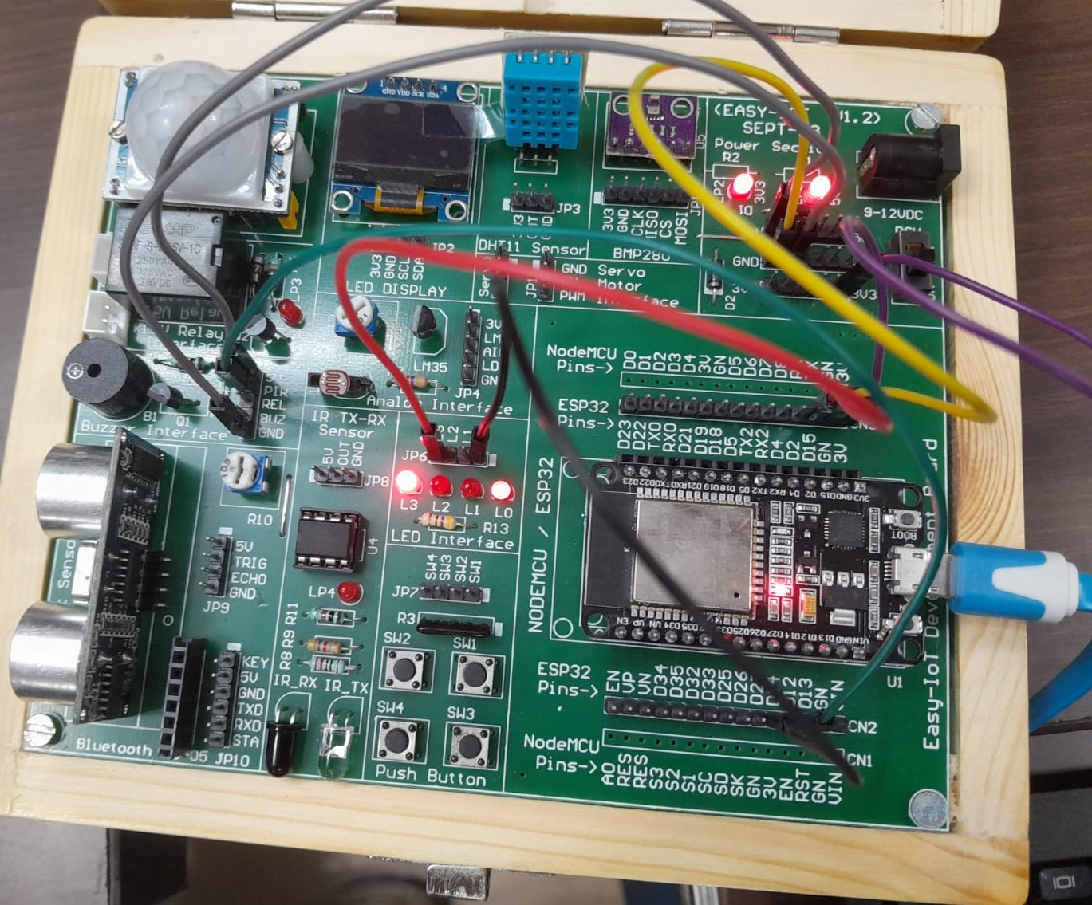

**Procedure:**

# Step 1: Declaring the variables

1. Declare the pins for motion detector, pin to show light intensity variation and the pin for showing how turning ON and OFF happens when motion is detected and no activity is sensed for 15 seconds.
2. Now make the physical connections for the same.
3. Now work on the other functions that will be responsible for controlling of the temperature of AC, light intensity and the coffee maker.
4. Inorder to make the code more user friendly and dynamic take the time as input from serial monitor with the help of keyboard in the form of 24 HOURS from the user.
5. Also print all the results like AC temperature and state of the coffee maker on the serial monitor .
6. Note down your observations.

# CODE:

# #include <BLEDevice.h>

# #include <BLEServer.h>

# #include <BLEUtils.h>

# #include <BLE2902.h>

# const int pirPin = 13; // PIR sensor pin

# const int ledPin = 2; // Room light control

# const int acPin = 4; // AC control pin

# const int coffeeMakerPin = 15; // Coffee maker control pin

# RTC_DATA_ATTR int bootCount = 0; // To count deep sleep wakeups

# int currentTime; // Placeholder for current time

# unsigned long lastMotionTime = 0; // To track last motion detected time

# bool displayActive = false; // To track if we are still sending messages

# // BLE Server and characteristic

# BLEServer* pServer = NULL;

# BLECharacteristic* pCharacteristic = NULL;

# bool deviceConnected = false;

# class MyServerCallbacks : public BLEServerCallbacks {

# void onConnect(BLEServer* pServer) {

# deviceConnected = true;

# }

# void onDisconnect(BLEServer* pServer) {

# deviceConnected = false;

# }

# };

# void setup() {

# Serial.begin(115200);

# // Initialize BLE

# BLEDevice::init("ESP32_SmartHome"); // BLE device name

# pServer = BLEDevice::createServer();

# pServer->setCallbacks(new MyServerCallbacks());

# // Create a BLE service

# BLEService *pService = pServer->createService(BLEUUID((uint16_t)0x180F)); // Using UUID 0x180F as an example (Battery Service)

# // Create a BLE Characteristic

# pCharacteristic = pService->createCharacteristic(

# BLEUUID((uint16_t)0x2A19), // Custom characteristic UUID

# BLECharacteristic::PROPERTY_READ | BLECharacteristic::PROPERTY_NOTIFY

# );

# // Add a descriptor

# pCharacteristic->addDescriptor(new BLE2902());

# // Start the service

# pService->start();

# // Start advertising the BLE server

# pServer->getAdvertising()->start();

# Serial.println("Waiting for a client connection...");

# pinMode(pirPin, INPUT);

# pinMode(ledPin, OUTPUT);

# pinMode(acPin, OUTPUT);

# pinMode(coffeeMakerPin, OUTPUT);

# // Initial state

# digitalWrite(ledPin, LOW);

# digitalWrite(acPin, LOW);

# digitalWrite(coffeeMakerPin, LOW);

# // Detect motion to wake up

# esp_sleep_enable_ext0_wakeup(GPIO_NUM_13, 1);

# bootCount++;

# Serial.println("Wake up from deep sleep, boot count: " + String(bootCount));

# // Simulated current time

# currentTime = 8; // You can modify this as per the current hour

# manageDevices(currentTime);

# }

# void loop() {

# // Check for motion detection

# if (digitalRead(pirPin) == HIGH) {

# Serial.println("Motion detected!");

# lastMotionTime = millis(); // Record the time motion was detected

# displayActive = true; // Start sending messages again

# // Control devices based on time

# manageDevices(currentTime);

# }

# // If 15 seconds pass without motion, stop sending messages (simulate display off)

# if (displayActive && millis() - lastMotionTime >= 15000) {

# if (deviceConnected) {

# pCharacteristic->setValue("No activity detected, stopping updates.");

# pCharacteristic->notify();

# }

# displayActive = false;

# }

# }

# void manageDevices(int time) {

# if (displayActive) { // Only manage devices if display is "active"

# // Control devices based on time

# if (time >= 7 && time < 11) {

# // 7 AM to 11 AM

# digitalWrite(ledPin, HIGH); // Light ON

# digitalWrite(acPin, LOW); // AC OFF

# digitalWrite(coffeeMakerPin, HIGH); // Coffee maker ON

# sendMessage("Light Intensity: 50%, AC Temp: 25C, Coffee Maker: ON");

# delay(30000); // Delay for 30 seconds

# sendMessage("Coffee is ready!");

# } else if (time >= 11 && time < 16) {

# // 11 AM to 4 PM

# digitalWrite(ledPin, HIGH); // Light ON

# digitalWrite(acPin, HIGH); // AC ON

# digitalWrite(coffeeMakerPin, LOW); // Coffee maker OFF

# sendMessage("Light Intensity: 75%, AC Temp: 20C, Coffee Maker: OFF");

# } else if (time >= 16 && time < 19) {

# // 4 PM to 7 PM

# digitalWrite(ledPin, HIGH); // Light ON

# digitalWrite(acPin, LOW); // AC OFF

# digitalWrite(coffeeMakerPin, HIGH); // Coffee maker ON

# sendMessage("Light Intensity: 100%, AC Temp: 25C, Coffee Maker: ON");

# delay(30000); // Delay for 30 seconds

# sendMessage("Coffee is ready!");

# } else if (time >= 19 && time < 22) {

# // 7 PM to 10 PM

# digitalWrite(ledPin, LOW); // Light OFF

# digitalWrite(acPin, HIGH); // AC ON

# digitalWrite(coffeeMakerPin, LOW); // Coffee maker OFF

# sendMessage("Light Intensity: 100%, AC Temp: 20C, Coffee Maker: OFF");

# } else {

# // 10 PM to 7 AM

# digitalWrite(ledPin, LOW); // Light OFF

# digitalWrite(acPin, LOW); // AC OFF

# digitalWrite(coffeeMakerPin, LOW); // Coffee maker OFF

# sendMessage("Light Intensity: 25%, AC Temp: 15C, Coffee Maker: OFF");

# }

# }

# }

# void sendMessage(const char* message) {

# if (deviceConnected) {

# pCharacteristic->setValue(message);

# pCharacteristic->notify();

# }

# }

# void enterDeepSleep() {

# Serial.println("Entering deep sleep mode...");

# esp_deep_sleep_start();

# }-

**Step 2: Note the readings of :**

1. Observe the Bluetooth connectivity.
2. Observe whether various functionalities operate correctly for different input time values.

**Photos of results-**

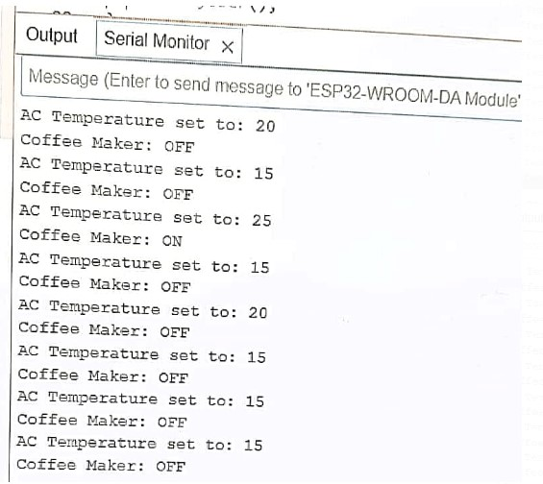

**Observations:**

1. **BLE Connectivity**: The ESP32 BLE server initializes as “ESP32_Smart_Home,” allowing real-time updates.
2. **Time-Based Adjustments**: Device states change based on preset times for lighting, AC, and coffee.
3. **Motion Detection**: The PIR sensor activates the motion LED, which turns off after 15 seconds of inactivity.
4. **Control Outputs**: Observations confirm that device states adjust as intended based on input time values.

**AC and coffee maker outputs are printed on the Serial Monitor, confirming they respond to time-based logic even though actual devices are not connected physically**.

**Conclusion:**

1. The BLE setup successfully communicates status updates.
2. Device automation adjusts correctly based on time, enhancing home automation.
3. Motion-triggered automation increases energy efficiency by limiting unnecessary device use.
4. Notifications enhance user experience by confirming smart home settings adjustments based on time and motion.